**Deploying the Project on Apache Tomcat 9**

**First Method**

1. First go to the project folder which is Form
2. Then go in Form folder of the project
3. In form folder there is Form-Web module go in that folder
4. In Form-Web there is target folder in that there is war file named Form-Web.war
5. Copy this file in the webapps folder of apache tomcat
6. Then start the apache tomcat from bin folder
7. In this way war file of the project will be deployed on the local server

**Second Method**

1. **Go to tomcat folder**
2. **Go to bin folder in tomcat**

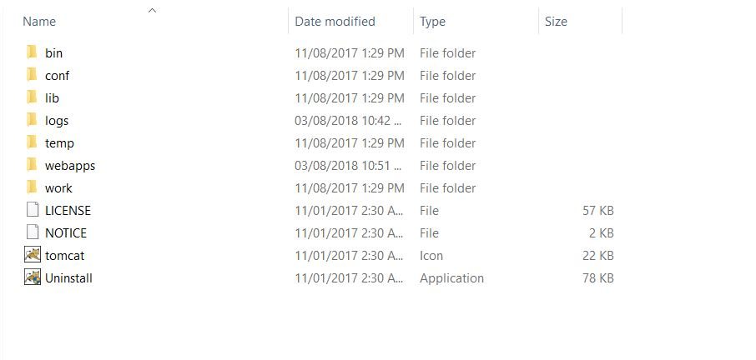

1. **Start tomcat9**

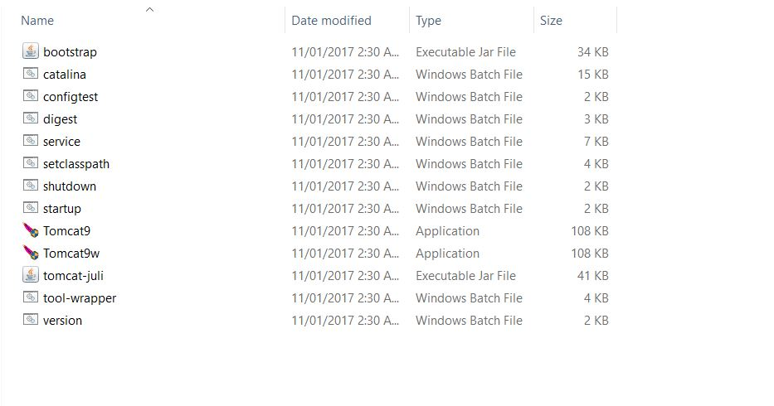

1. **Go to ManagerApp by using localhost:9999 whatever port number given while tomcat installation**

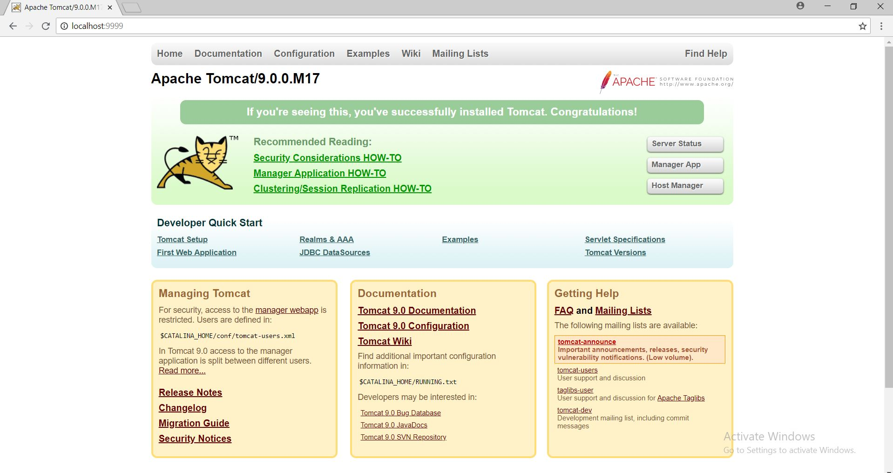

1. **After login Deploy the war file by using deploy file option add the war file of the project and deploy it by using Deploy click.**



1. **Click on the deployed link Form-Web**

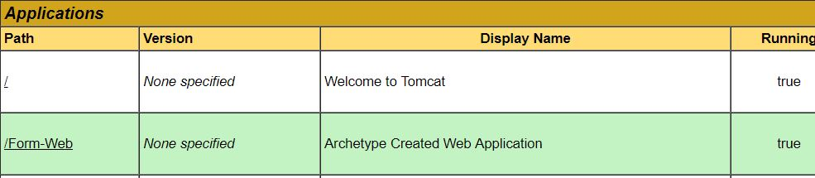

1. **After clicking on Form-Web link the enquiry form will be opened in browser**

